e-ASIA Joint Research Program (the e-ASIA JRP)
Research Cooperation in the field of ‘Alternative Energy’
on the topics of
‘Urban and biological wastes to energy, useful biochemicals, and biofuels’, ‘New fuel cell science and technologies’ and ‘Alternative energies in the tropics and sub-tropics’
11th Joint Call for Proposals to be submitted by 30 March 2022

The e-ASIA Joint Research Program (hereinafter referred to as the “e-ASIA JRP”) aims to develop a vibrant and collaborative research community in Science and Technology, to promote innovation in the East Asian region, and to contribute to the region’s economic development. As part of the program, the following Member Organizations of the e-ASIA JRP have agreed to implement a joint call for proposals of multilateral cooperative research activities.

- Japan: Japan Science and Technology Agency (JST)
- Myanmar: Ministry of Science and Technology (MOST)
- Philippines: Department of Science and Technology – Philippine Council for Industry, Energy and Emerging Technology Research and Development (DOST-PCIEERD)
- Singapore: Agency for Science, Technology and Research (A*STAR)
- Thailand: Program Management Unit for Human Resources & Institutional Development, Research and Innovation (PMU-B)

I. Aim of Joint Call and Research Area

The aim of the e-ASIA JRP 11th Call in the field of Alternative Energy is to invite applications for scientific ideas and technical solutions to address the green energy demands in Southeast Asia, solve related environmental issues, and help mitigate global climate changes. It is also anticipated that the technical solutions developed through projects supported in this grant call could contribute to the economical and societal advancement in the region.

Climate changes, particularly the global temperature rising, are posing serious threat to the eco-system, resulting in the diminishing of biodiversity, sea-level rise, as well as other unpleasant consequences. Southeast Asia with its tropical climate allows for fast growing of plants, while also leaves large quantity of plantation waste after each harvest. Despite government regulation and control, burning of plantation waste takes place here and there, now and then, which discharges not only more heat to the space, but also harmful particles which severely compromise the air-quality in much broader region hundreds of kilometers away. This remains one of main issues to be solved through collective effort of the ASEAN communities.

Renewable energy sources combined with green energy technology is another venue which could help us fight the climate change, while improve the life of people in remote rural areas. Fuel cell technology is a promising candidate for such purpose. By converting fuels to electrical power, fuel cells can directly power various applications, including transportations. With a continuous supply of fuel and oxygen (usually from air), non-intermittent electricity are generated for convenient use upon demands.

Electricity in Southeast Asia can also be generated by directly harvesting the rich energy sources provided by nature, such as sunshine, wind, sea waves, and raining, etc. which carry energy at different amplitude. Solar panel, windmill, and water-turbine are already widely used for this purpose. Are there devices/systems which can allow us to concurrently harvest multiple energy in high efficiency?

In light of these demands and opportunities, we would like to call for proposals to be submitted in the following 3 areas of research in this grant call.

1) Urban and biological wastes to energy, useful biochemicals, and biofuels

The biomass/biowastes can be good resource to produce useful biochemicals and materials such as high quality porous carbons, nanocarbon hybrid materials, and various carbon materials with high-functionality and high-performance for various applications, including supercapacitors and metal-air batteries. The removal and transportation of such biowastes incur notable cost, eroding profit margins and hence making their applications less attractive. Urban biological wastes are another issue to tackle due to the mixture nature. The advantage is that they are currently collected and can be transported to vicinity areas for further treatment where conversion to energy can be an option.

Proposals focusing on localized use of biomass to generate energy through green processes, or efficient use of urban biowastes to produce energy and fuels with and without useful by-products (biochemicals and materials), are welcome. Incorporation of novel green approaches to remove the plantation waste, green conversion of biomass to chemicals (via environmentally friendly (non-toxic) synthesis) can also be a focus of proposal.

2) New fuel cell science and technologies

There are more than 20 different type of fuel cell technologies available,^{[1]} including proton-exchange membrane fuel cell (PEMFC), alkaline fuel cell (AFC), direct formic acid fuel cell (DFAFC), direct methanol fuel cell (DMFC), solid oxide fuel cell (SOFC), etc. Do any of these fuel cell technologies work well for biomass-derived fuels? What new science can be developed to support greener and more efficient cost-effective biomass-derived fuel cell development? What new fuel cell technologies can be considered?

Proposals that attempt to answer these questions are highly desirable. Feasibility analysis with primary data adds merits to the proposal.

Ref [1]. https://en.wikipedia.org/wiki/Fuel_cell

3) Alternative energies in the tropics and sub-tropics

Examples include windmill with laminated solar panel, and thermoelectric devices integrated solar panels, etc. Apart from energy harvesting, distributed renewable energy storage based on batteries, heat pump storage, hydrogen production, etc. is also critical, as it offers flexibility and cost-advantages and potentially has better acceptance in technology adoption. Integration of various types of renewable energy can also make the energy systems more flexible. How to maximize the efficiency of such energy harvesting? What would be the ideal batteries or other energy storage devices for tropical and sub-tropical renewable energy storage?

Proposals that address this demand in all possible ways. Feasibility analysis with primary data adds merits to the proposal.

II. Support/ Funding Modality
In principle, each Member Organization will support its own country’s researchers in a selected research project in this joint call with the type of support defined as “Funding Modality” in the following table below. The duration of a selected research project will be three years (36 months), in total, from the start date. Details of conditions of support will vary by Member Organization. Applicants shall refer to the Appendix for each Member Organization’s rules and regulations.

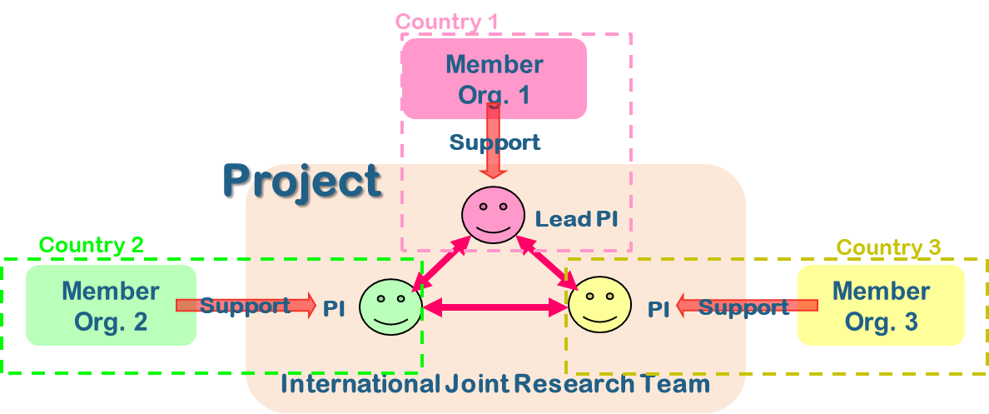

(1) Urban and biological wastes to energy, useful biochemicals, and biofuels
Participating Member Organizations | Funding Modality
- Japan: Japan Science and Technology Agency (JST) | New
- Myanmar: Ministry of Science and Technology (MOST) | In-Kind
- Philippines: Department of Science and Technology – Philippine Council for Industry, Energy and Emerging Technology Research and Development (DOST-PCIEERD) | New
- Singapore: Agency for Science, Technology and Research (A*STAR) | New
- Thailand: Program Management Unit for Human Resources & Institutional Development, Research and Innovation (PMU-B) | New, In-Kind

(2) New fuel cell science and technologies
Participating Member Organizations | Funding Modality
- Japan: Japan Science and Technology Agency (JST) | New
- Philippines: Department of Science and Technology – Philippine Council for Industry, Energy and Emerging Technology Research and Development (DOST-PCIEERD) | New
- Singapore: Agency for Science, Technology and Research (A*STAR) | New
- Thailand: Program Management Unit for Human Resources & Institutional Development, Research and Innovation (PMU-B) | New, In-Kind

(3) Alternative energies in the tropics and sub-tropics
Participating Member Organizations | Funding Modality
- Japan: Japan Science and Technology Agency (JST) | New
- Philippines: Department of Science and Technology – Philippine Council for Industry, Energy and Emerging Technology Research and Development (DOST-PCIEERD) | New
- Singapore: Agency for Science, Technology and Research (A*STAR) | New
- Thailand: Program Management Unit for Human Resources & Institutional Development, Research and Innovation (PMU-B) | New, In-Kind

New: Each Member Organization will support a selected project by new funding

Re-budgeting: Funds already allocated to an existing project by each Member Organization will be reallocated to the e-ASIA JRP

In-kind: Each Member Organization of his/her country does not provide budget for a selected project. A researcher participating in a selected project will use funds that are already available, but no additional fund will be provided by each Member Organization from his/her country. In principle, at least one country must participate via “new” or “re-budgeting” funding modality. In other words, proposals cannot be accepted if all the applicants intend to participate through an “in-kind” basis.

III. Application
In addition to the following common requirements, there are specific rules clarified by each Member Organization. For specific rules by each Member Organization, please refer to the Appendix or consult the person noted in Section VI.

III-1. Applicant/ Project Consortium
A project consortium must be consisted of at least three eligible research teams from at least three different participating countries listed above.

Each research team shall be led by a Principal Investigator (PI), and a consortium shall be led by a Lead Principal Investigator (Lead PI) specified among the PIs.

The Lead PI will be responsible for running and managing the project. The Lead PI will be the contact point with the e-ASIA JRP Secretariat on behalf of the whole consortium and is responsible for the administrative management of the complete project, should it be awarded supporting. In addition, the Lead PI is responsible for leading the project activities at his/her own institution. The Lead PI must be affiliated with an institution situated in one of the participating countries in this call.

All PIs must fulfil their respective domestic eligibility rules for research application. Researchers from industry are encouraged to participate in the collaboration in accordance with domestic eligibility rules. PIs should contact the person noted in Section VI for information on their respective domestic eligibility rules.

III-2. Proposal Submission
Proposals must be submitted from the Lead PI by e-mail to the e-ASIA JRP Secretariat at the e-mail address specified below. Applications shall be written in English.

Deadline for Submission:
17:00 (Thai Standard Time, UTC+7) 30 March 2022

Please submit the proposal to:

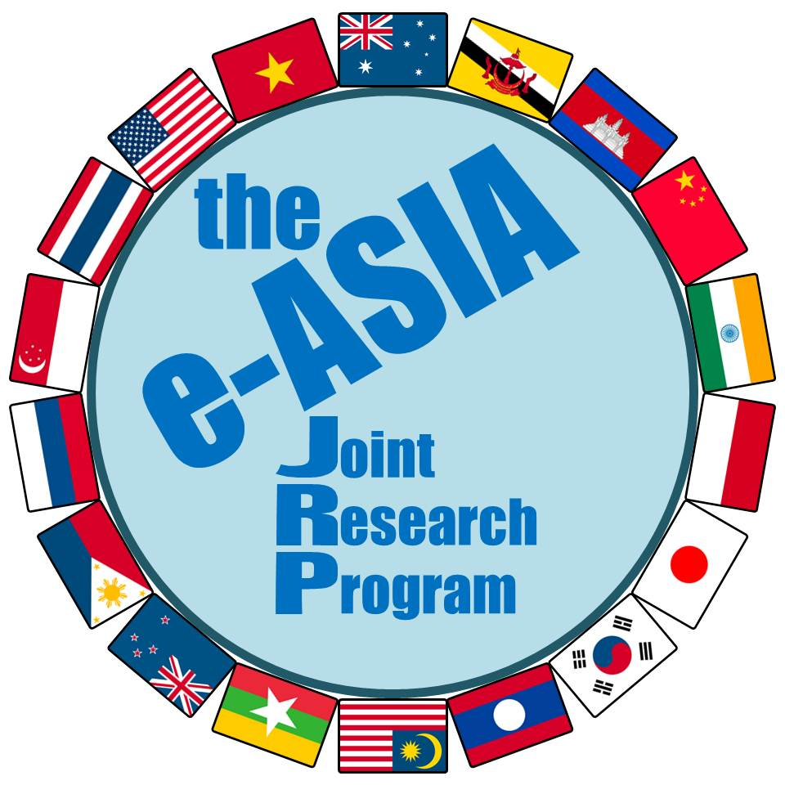
Ken Kawabata (Mr.)
e-ASIA JRP Secretariat
E-mail: easia_secretariat@jst.go.jp

Note1: The e-ASIA JRP Secretariat will send a confirmation email to the Lead PI to confirm receipt of his/her proposal. In case the Lead PI does not receive a confirmation e-mail from the e-ASIA JRP Secretariat within one week, they should contact the e-ASIA JRP Secretariat at the address above. The e-ASIA JRP Secretariat does not assume any responsibility for delay or error in e-mail delivery.
Note2: Application forms sent by any method other than e-mail (such as post, fax or telex) will be rejected.

< Important Notice to ALL PIs >

Make sure to submit all necessary application documents requested by each Member Organization of your country, in addition to the application to the e-ASIA JRP Secretariat (submitted by Lead PI only), because each Member Organization may request applicants of its country to submit another form of proposals with another deadline date. Proposals shall satisfy both common requirements written in this call guideline and individual requirements requested by each Member Organization. A research team that does not satisfy individual requirements of the Member Organization of your country will not be deemed as eligible research team.

For individual requirements by each Member Organization, please refer to the Appendix or consult the person noted in Section VI.

The proposal shall include:
- Project description including how the collaboration will be carried out, with clear statements of what roles each country's researchers will play respectively in the project;
- Description of the expected outcomes of the proposed project, scientifically as well as in terms of relevance for industry and society;
- Description of the ongoing activities and specific advantages of each group respectively, which form the basis for the proposed joint project;
- Description of the expected value added from the proposed joint project, including how the competence, technology and other resources in each group complement each other;
- Description of how the project is expected to help strengthen multilateral research collaboration over the longer term;
- Description of the expected value added from the multidisciplinary approach in the proposed joint project; and
- Description of how the proposed joint project interacts with or impacts other comparable activities worldwide.

III-3. Application Forms
Researchers should prepare the following application (proposal) forms in English (“E”).
For further requirements by each Member Organization, researchers shall refer to the Appendix or shall consult each Member Organization of his/her country.

Form 1E Application outline (title, acronym, general description and proposed period of cooperative research project)
Form 2E Summary of the project
Form 3E Research leaders’ information (their CVs*)
Form 4E Research team (list of individuals committed to the cooperative research project in each country)
Form 5E Description of the cooperative research project
Form 6E Research networking plan
Form 7E Plan to nurture early career researchers
Form 8E Budget plan for the project
Form 9E Research infrastructures and funds from other sources

* The description of Curriculum Vitae (CV) from each PI shall include basic information on education, past and present positions, membership of relevant organizations/associations and a publication list in the past 5 years.

In addition to the documents above, all projects must comply with ethical review and requirements of each Member Organization, especially for research activities related to human and animal subjects. PIs shall refer to the Appendix for each Member Organization’s ethical requirement.
IV. Evaluation
IV-1. Evaluation Process
A proposal will be evaluated at each relevant Member Organization of the project consortium, according to the evaluation criteria clarified in the following subsection.
Based on the results of the evaluation conducted at each Member Organization, a final decision will be made at the joint panel meeting among the participating Member Organizations, followed by approval at the e-ASIA JRP Board Meeting.

IV-2. Evaluation Criteria
Proposals will be evaluated according to the following common e-ASIA JRP evaluation criteria, incorporated with evaluation criteria clarified by each Member Organization. For the evaluation criteria clarified by each Member Organization, please refer to the respective Appendix or consult each respective Member Organization.

1) Regional Relevance of the Research
The research activity should contribute to:
- The advancement of scientific discovery;
- The development of science and technology in the region; and
- The resolution of significant relevant issues across the region.

2) Mutual Benefits of the Joint Research
Activities of mutual benefit to the collaborators and their institutions are desirable. Mutually beneficial in the sense that the projects utilize unique opportunities the e-ASIA JRP will provide that could not be achieved either through bilateral or individual research but only through multilateral cooperation.

3) Effectiveness of Exchange
The project should:
- Contain activities to nurture early career researchers through research activities;
- Contain activities to engage female researchers where strengthening capacity is needed; and
- Enhance research capacity in the region.

IV-3. Notification of the Final Decision
The Lead PI will be notified the final decision by the e-ASIA JRP Secretariat as soon as the final decision is taken and approved by all Member Organizations in the e-ASIA JRP. (Approximate implementation of the notification: November to December 2022)

V. Project Implementation
Project reporting will be in accordance with the respective Member Organization’s rules. Please contact respective Member Organizations for more details.
In addition to the Member Organization’s requirements, the consortia are expected to deliver Progress Reports and Final Reports to the e-ASIA JRP Secretariat, in English, including a description of their collaboration and a publishable summary of the project status. The Progress and Final Reports will be reviewed by the Board and Scientific Advisory Council. It is also encouraged that the project proactively disseminates its achievements to the public.

V-1. Progress Report
In the middle of research period (i.e., after one and a half year), the lead PI shall promptly develop and submit an integrated progress report to the e-ASIA JRP Secretariat on the status of the joint research.

V-2. Final Report
A final report shall be developed and submitted by the Lead PI to the e-ASIA JRP Secretariat within two months after the completion of the joint research period.

V-3. Others
All the researchers/research institutions organizing a consortium are strongly recommended to conclude a Collaborative Research Agreement (hereinafter referred to as “CRA”) to assure optimal understanding and coordination among the collaborating scientists working on each project before project starts. CRA should, with due respect to the researchers’ institutions and the Member Organizations’ intellectual property and data handling policy, include the treatment of intellectual property rights, handling of confidential information, publication of research results, warranty and indemnification, and access to and transfer of the relevant materials. Applicants shall refer to the Appendix for each Member Organization’s requirement.

VI. Contact information
Applicants should contact the following for information on each Member Organization’s eligibility rules or support conditions:
Also please refer to the Appendix for information of each Member Organization.

Country: Member Organization | Contact Point
- Japan: Japan Science and Technology Agency (JST) | Mr. Masayoshi Higuchi, Mr. Hideaki Kodani and Ms.Wakana Yamanaka  TEL: +81 (0)3-5214-7375  E-mail: easiajrp@jst.go.jp
- Myanmar: Ministry of Science and Technology (MOST)  Department of Research and Innovation (DRI) | Dr. Cho Cho Lwin  Deputy Director  Department of Research and Innovation  Tel: +95-1-663451  E-mail: Irtc.dri.headoffice@gmail.com
- Philippines: Department of Science and Technology – Philippine Council for Industry, Energy and Emerging Technology Research and Development (DOST-PCIEERD) | Dr. Enrico C. Paringit  Tel: +639178113147  E-mail: enrico.paringit@pcieerd.dost.gov.ph
- Singapore: Agency for Science, Technology and Research (A*STAR) | Ms. Nurhidaya Shadan  Office of Grants Administration, Enterprise  Tel: +65 64196541  E-mail: programmatic_ame@hq.a-star.edu.sg
- Thailand: Program Management Unit for Human Resources & Institutional Development, Research and Innovation (PMU-B) | Dr. Doungkamon Phihusut  Tel: 2109 5432 ext. 842-843  E-mail: pmu.b@nxpo.or.th

Applicants should contact the following for general inquiries:

Ken Kawabata (Mr.)
e-ASIA JRP Secretariat / Japan Science and Technology Agency
Room 218 Innovation Cluster1 Building
National Science and Technology Development Agency (NSTDA)
111 Thailand Science Park, Phahonyothin Road
Khlong Nueng, Khlong Luang, Pathum Thani 12120 THAILAND
Tel: +66-2-564-7713 H/P: +66-61-421-0316
E-mail: easia_secretariat@jst.go.jp

e-ASIA Joint Research Program (the e-ASIA JRP)
Research Cooperation in the field of ‘Alternative Energy’
on the topics of
‘Urban and biological wastes to energy, useful biochemicals, and biofuels’, ‘New fuel cell science and technologies’ and ‘Alternative energies in the tropics and sub-tropics’

11th Call for Proposals to be submitted by 30 March 2022

Information about each Member Organization (alphabetical order by country)

- Japan: Japan Science and Technology Agency (JST)
- Myanmar: Ministry of Science and Technology (MOST)
- Philippines: Department of Science and Technology – Philippine Council for Industry, Energy and Emerging Technology Research and Development (DOST-PCIEERD)
- Singapore: Agency for Science, Technology and Research (A*STAR)
- Thailand: Program Management Unit for Human Resources & Institutional Development, Research and Innovation (PMU-B)

- Japan: Japan Science and Technology Agency (JST)

Japan-based applicants must complete all the requirements designated by JST. Information on additional requirements applied to Japan-based applicants are available at the official domestic call announcement on the JST website.

JST’s official call announcement:
https://www.jst.go.jp/inter/program/announce/announce_easia_jrp_11th.html
I. Eligibility for Japan-based applicants
- Any independent researcher personally affiliated with and actively conducting research at a domestic Japanese research institution (or who will fulfil this requirement by the start of the research project), regardless of nationality, is eligible to apply as a Principal Investigator.
Note: “Domestic Japanese research institution” in Japan refers to universities, independent administrative institutions, national/public testing and research institutions, specially authorized corporations, public‐service corporations and enterprises, etc. that must satisfy predetermined requirements designated by the Ministry of Education, Culture, Sports, Science and Technology (MEXT).
Japan-based researchers from industry are also eligible to apply as a Principal Investigator in the joint research project in the Japan-based team.
- Early career researchers who completed his/her doctorate in the last 10 years are strongly encouraged to apply.

II. Support
II-1. Funding Modality
JST will support each Japan-based team with a “new fund” up to 27 million Japanese Yen as direct cost for 36 months. The overhead cost of 30% of direct cost will be added separately. The budget for a project may differ each year, depending on the content of activities. The amounts will be adjusted each year due to the budgetary limitations for this program.

II-2. Expenditure/costs eligible for funding
This program is designed to support expenses related to cooperation by a Japan-based researcher with their counterparts, such as expenses for travel and/or conducting seminars/symposia.
Funding provided within this call is intended to enhance the capacity of the applicants to collaborate. Funding will therefore be provided mainly in support of collaborative activities but may also cover some of the local research costs that are necessary for the collaboration. In principle, eligible direct costs are those costs directly necessary for accomplishing the research, indicated below. Please refer to the guidance documents available at the following link for further details of eligible direct costs:
https://www.jst.go.jp/inter/research/contract/contract.html (in Japanese only).
1. Eligible Direct Costs:
- Facilities, Equipment and Consumables: costs of research equipment, spare parts, prototypes,
- Travel Costs: travel costs and associated living expenses of the project members registered in the project plan, and travel costs of inviting external experts.
- Salaries and Honoraria: salaries of the researchers, temporary staff, PhD students, post‐docs, etc., who are hired for the research, and other costs such as honoraria for invited lecturers.
- Others: costs for organizing meetings in Japan including rental costs for the venue, food & beverage (excluding alcohol) costs and other costs which are deemed to be necessary for organizing the event. Expenses for creating software, renting or leasing equipment, transporting equipment, etc.

2. Overhead cost shall be 30% of direct costs.
Note: Please refer to the following link for the provisions regarding indirect costs:
https://www8.cao.go.jp/cstp/compefund/shishin1_tekiseisikkou.pdf (in Japanese only).

II-3. Payments
Payments will be made according to a contract for commissioned research entered into between JST and a ”Domestic Japanese Research Institution”. The contract for commissioned research will be renewed each year over the cooperative research period. Since the contract is agreed on condition that all administrative procedures related to this project will be handled within the institution, the PI should consult with the department in charge at his/her institution.

III. Application
Applicants of each Japan-based team are required to complete necessary submission as specified below.

III-1. Submission of Application Forms (Form E1-E9) (from the Lead PI)
Proposals must be submitted by e-mail to the e-ASIA JRP Secretariat.

III-2. Additional Application Forms (For Japan-based applicants only)
In addition to the common Application Forms in English (Form E1-E9), Japan-based applicants are required to complete and submit additional application forms in Japanese (Forms 1J and 2J) to JST by “e-Rad” (https://www.e-rad.go.jp/index.html).

- Forms 1J and 2J are available from the JST website:
https://www.jst.go.jp/inter/program/announce/announce_easia_jrp_11th.html
(in Japanese only)

- The deadline for the “e-Rad” submission:
19:00 (Japan Standard Time) 30th March 2022(TBD)

IV. Evaluation of Project Proposals
Independent Committees consisting of experts will evaluate all proposals. Based on the results of the evaluation, a common decision will be decided jointly among Member Organizations participating in the call regarding funding of the selected proposals.

IV-1. Evaluation Criteria
The following evaluation criteria, incorporated with the e-ASIA JRP evaluation criteria (see IV-2. Evaluation Criteria in the Call Guideline), will apply to each application:

- Conformity with Program Aims and Designated Research Fields
The proposed activity shall conform to the aims of the program and the research fields that the program designates. In addition, the applicants shall already have a good research foundation for their proposed activity.

- Capability of Principal Investigators
The principal investigators of collaborating countries shall have the insight or experience for pursuing the activity and the ability to manage the cooperation and reach the project goals during this program’s period of support. The call aims to take into account the potential of early career researchers who have completed their doctorate in the last 10 years in this role.

- Effectiveness and Synergy of Cooperative Research Project
The proposed research activity shall be eminent, creative and at an internationally high level in an attempt to produce a significant impact on the development of future science and technology or to solve global and regional common issues or to create innovative technological seeds that can contribute to the creation of new industries in the future.
Moreover, proposed research activities that can be expected to create synergy through collaborative research with the counterpart institution will be preferred. Such synergy could be attained through, for example, the acquisition and/or application of knowledge, skill and/or know-how of the counterpart researcher.

- Validity of Research Plan
The sharing of research activities with the counterpart research institution and the planning of research expenses shall be adequate to realize the proposed research activity.

- Effectiveness and Continuity of Exchange
Activities characterized by the following examples shall be involved to enhance sustainable research exchange and networking.
    - Nurturing of researchers through human resource exchange.
    - Sustainable development of research exchange with the counterpart countries initiated by this activity.
    - Enhancing the research network between collaborating countries including researchers other than the research leader and members of this activity.
    - Improving the presence of science and technology in Japan and the counterpart country.

- Validity of Exchange Plan
The planning of exchange activities and their expenses with the counterpart research institute shall be adequate to realize the proposed research activity.

V. Project Implementation/Publications and Intellectual Property
Selected collaborative research projects in this call are expected to start in April 2023, but the schedule is subject to future adjustment due to budgetary conditions.
The PIs are obliged to publish research results obtained in the program with acknowledgement of the support received.
PIs supported in this call are required to conclude a Collaborative Research Agreement listing the rights and responsibilities of each project partner, and including regulations on the handling of Intellectual Property Rights. This Agreement shall be signed among the institutions participating in the project.
Scientific and technological outcomes and any other information derived from the collaborative activities supported in this call can be announced, published or commercially exploited with the agreement of all partners in a supported project and according to their national regulations as well as international agreements concerning intellectual property rights.
As for the contract between the “Domestic Japanese research institution” and JST, it stipulates that Article 17 of the Industrial Technology Enhancement ACT (so-called Japanese version of the Bayh-Dole Act) and Article 25 of the ACT on Protection of the Creation, Protection and Exploitation of Content (tentative translation) will be applied to all intellectual property rights belonging to the Japanese institution generated as a result of this project.

VI. Reporting
VI-1. Progress report to JST
At the end of each fiscal year, the PI of the Japan-based team shall promptly submit an annual progress report on the status of research exchange, and the institution with which the PI is affiliated shall promptly submit a financial report on research expenses to JST.

VI-2. Final report to JST
After completion of the period of joint research, the Japan-based team’s PI shall submit within two months a final report on the results of the joint research. The final report shall include a general summary compiled jointly by all members of the Japan-based research group.
The institution with which the PI is affiliated shall submit a financial report on research expenses within the same time frame.

VII. Contact Information
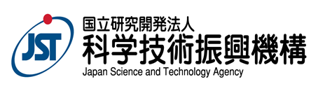

Mr. Masayoshi Higuchi, Mr. Hideaki Kodani, Ms. Wakana Yamanaka
Department of International Affairs
Japan Science and Technology Agency (JST)
Tel: +81(0)3-5214-7375 Fax: +81(0)3-5214-7379
E-mail: easiajrp@jst.go.jp

- Myanmar: Ministry of Science and Technology (MOST)

- Funding modality
  - In-Kind

- Eligibility criteria
  - The applicants must be Researchers and /or University Professors/Instructors who work in Public and Private Institute or University in Myanmar., and are competent in conducting a Research with International Partners.

- Contact point
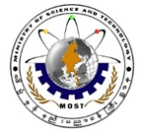
Dr. Cho Cho Lwin
Deputy Director
International Relation and Technical Cooperation Division
Department of Research and Innovation
Ministry of Science and Technology, Myanmar
No.6, Kabar Aye Pagoda Road, Yankin Township, Yangon, Myanmar
Tel: + 95-1- 663451 H/P: +95-1- 664930

Foreign Relation Department
Ministry of Science and Technology
Office Number(21), Naypyitaw, Myanmar

- Philippines: Department of Science and Technology – Philippine Council for Industry, Energy and Emerging Technology Research and Development (DOST-PCIEERD)

The national call announcement will be published in the DOST-PCIEERD website: www.pcieerd.dost.gov.ph
- Eligibility Requirements
(1) Any Filipino connected with public and private universities and colleges and Research and Development Institutes, with proven competence may apply for funding support provided that projects fall under the specific research areas.
(2) The eligibility of the Philippine Principal Investigator shall be determined by DOST-PCIEERD based on his/her readiness in terms of technical, managerial, financial, and marketing capabilities (if necessary). As such, the proponent shall submit documents/proof of the following: credentials/proof of capability, track record (e.g. ongoing and previous project/s implemented in the past), and endorsement of his/her institution, must not have any existing accountability with DOST and its agencies particularly technical and financial reports, and must not have pending administrative or criminal case involving financial transactions. The Philippine Principal Investigator must possess at least a Master’s degree in a relevant field.

- Support
Three (3) projects could be supported under this call. Budget range of US $300,00 – 350,000 per project for 3 years shall be provided by DOST-PCIEERD to support the collaborative projects.

- Application
Interested parties should submit their proposals using the DOST-GIA proposal format through the DOST E-proposal portal, http://dpmis.dost.gov.ph before the Closing Date on 01 April 2022: Together with the proposal, DOST-PCIEERD requires submission of a formal letter of intent from the applicant and an endorsement from the authorized head of organization. The authorized head of the organization will also be the principal signatory of their organization for the research agreement award.

- Evaluation of Project Proposals
Review teams (Project Managers, Technical Experts Team or Technical Panel, and DOST-PCIEERD Management Team) will evaluate each proposal based on the following criteria: alignment to the Call, no duplication with previous or existing researches, scientific merit, technical feasibility, soundness of methodology, financial viability (commensurate to intended output and potential impact), potential socio-economic merits, environmental impact (e.g. does not pose significant adverse to the environment or will/can improve environmental conditions), and marketability (e.g. potential adoption/use of the industry (manufacturer) and other partners). Each proposal will be given a numerical score and will be ranked accordingly. Preliminary funding recommendations will be forwarded to the DOST-PCIEERD Governing Council based on this ranking.

The DOST-PCIEERD Governing Council, based on the rankings and preliminary recommendation of the DOST-PCIEERD evaluation teams, will make final funding decisions for the DOST-PCIEERD counterpart before forwarding the proposals to the joint panel of the participating Member Organizations and the e-ASIA JRP Board Meeting for final funding decisions.

- Reporting
Semi-annual and a detailed final progress and financial reports will be required. The final reports must be submitted within 90 calendar days after the completion of the period of performance. Required forms are downloadable from the DOST-PCIEERD website and may be provided by the DOST-PCIEERD upon the awarding of the agreement to eligible applicants

VI. Contact Information

Dr. Enrico C. Paringit
Executive Director
Philippine Council for Industry, Energy and Emerging Technology Research and Development (PCIEERD)
Department of Science and Technology (DOST)
4thand 5thLevels, Science Heritage Building, DOST Compound,
Gen. Santos Ave., Bicutan, Taguig City
Tel: +639178113147; (632) 837-2071 locals 2100, 2121, 2120
E-mail: enrico.paringit@pcieerd.dost.gov.ph

- Singapore: Agency for Science, Technology and Research(A*STAR)

A*STAR’s official call announcement:
https://www.a-star.edu.sg/Research/funding-opportunities
I. Eligibility for Singapore-based applicants

- Lead PI/PI must be an independent researcher from public sector research performers, namely the Institutes of Higher Learning (universities and polytechnics), A*STAR Research Institutes, as well as other non-defence-related public sector agencies (e.g., Ministries, Statutory Boards).

- Lead PI/PI must hold a primary appointment of at least 75% in a local publicly funded institution and salaried by the institution.

II. Support

II-1. Funding Principles
For the e-ASIA JRP 11th Call in the field of Alternative Energy, up to four (4) projects from Singapore-based applicants can be supported, each with a budget of S$300,000 (inclusive of 30% indirect cost) for project duration of 36 months.

Funding provided within this call is intended to enhance the capacity of Singapore-based applicants to collaborate with their international counterparts, these include local research costs as well as expenses for travel and/or conducting seminars/symposia.

A list of non-fundable direct cost items is provided below:

Type of Expenses | Description
Salaries of Lead PI / Investigators  / Visiting Professors & researchers/ Collaborators/ general administrative support staff | Not allowable.
Teaching buy outs | Not allowable for the hiring of substitutes to perform the Investigators’ teaching duties.
Stipend top-up for existing post-  graduate scholarship holders | Not allowable.
Undergraduate stipend and tuition support | Not allowable.
Costs related to general administration and management. | Not allowable.
Costs of office or laboratory space | Not allowable.
Personal productivity tools & communication expenses | Not allowable, unless the use of mobile phones and other form of smart devices were indicated in the methodology for the Research.
Audit fees (Internal and external audit) and Legal fees | Not allowable.
Entertainment | No allowable.
Refreshment | Not allowable.
Fines and Penalties | Not allowable.
Patent Application | Not allowable. This includes patent application filing, maintenance and other related cost.
Professional Membership Fees | Not allowable.
Staff retreat and team-building activities. | Not allowable.

III. Application

Interested applicants to submit their proposals via e-mail to the e-ASIA JRP Secretariat, copying the Point of Contact from A*STAR identified below, before the Closing Date on 30 March 2022.

Note: applications must be endorsed by the applicants’ Host Institution(s) prior to submission.

IV. Evaluation of Project Proposals

Proposals will undergo a peer review round before proceeding to a joint panel evaluation with other Member Organisations for final funding recommendation. Subsequently, selected proposals will be approved at the e-ASIA JRP Board Meeting.

IV-1. Evaluation Criteria

In addition to the evaluation criteria set by the e-ASIA JRP (see IV-2. Evaluation Criteria in the Call Guideline), the following evaluation criteria will be applied to each Singapore-based application:

- Novelty and originality of the proposed idea or concept
- Are the aims original and innovative?
- Does the project employ novel approaches or methods and/or will generate novel products or processes?
- Is the proposed methodology feasible/viable?

- Quality of Science
- Would the outcomes of the project lead to scientific excellence in the proposed field of research?

- Competitive / comparative advantage, potential for commercial exploitation
- How competitive is the proposal internationally?

- Capability of the research performers to conduct the research
- Does the research performer/team possess the necessary expertise and competences to conduct the research successfully?

- Collaborative advantage of the Lead PI/PI and academic/industry collaborator(s)
- Are there synergies between the Lead PI/PI and the academic and industry partners in this collaboration?
- Do all the partners bring in significant and/or unique contributions to the research?
- Does the project contribute to and benefit from an equitable and balanced cooperation?

V. Reporting

V-1. Progress report to A*STAR

Each awarded project will be evaluated and assessed for progress to ensure that the proposed milestones and deliverables can be achieved. Successful grant applicants will be required to submit an annual progress report to A*STAR via the Integrated Grant Management System (IGMS).

VI-2. Final report to A*STAR

Singapore-based applicants are required to submit a final report on the results of the joint research within three (3) months following the end of the project term.

Additionally, the Institutions are required to submit a Final Claims / Final Statement of Account within six (6) months from the end of the project term.

VI. Contact Information

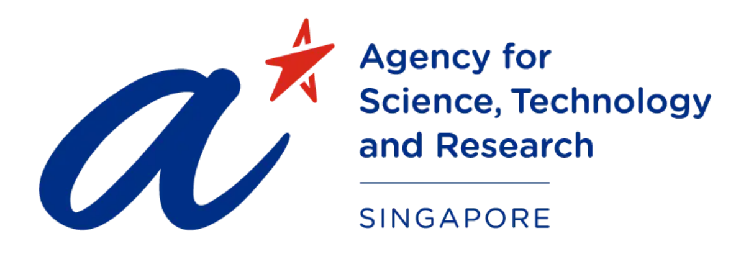

Ms. Nurhidaya Shadan
Office of Grants Administration, Enterprise
Agency for Science, Technology and Research (A*STAR)
Tel: +65 64196541
E-mail: programmatic_ame@hq.a-star.edu.sg

- Thailand: Program Management Unit for Human Resources & Institutional Development, Research and Innovation (PMU-B)

I. Eligibility for Thai applicants
The applicants must be researchers and/or university professors/instructors who work in public/non-profit organization research institute or university in Thailand, and are competent in conducting a research with international partners. PMU-B has interests in the following areas
1) Urban and biological wastes to energy and biofuels
2) New fuel cell science and technologies
3) Alternative energies in the tropics and sub-tropics

II. Support
The total budget for the Thai researcher over a full 3-year period is up to 5,000,000 THB per project. The budget for a project may differ each year, depending on the content of activities and compliance with PMU-B financial guideline (please find details via PMU-B website: https://www.nxpo.or.th/B/).

III. Evaluation of Project Proposals
Proposals will be peer-reviewed, and evaluated by a committee. The final selection will be done by the international selection committee of e-ASIA.

III.I Evaluation Criteria
To be funded, proposals must be internationally competitive. It should lead to the advancement of the research field, or novel applications or increase of research capacity.
Key evaluation criteria are:
- Significance and impact of the research
- Scientific Rationale: novelty, importance and timeliness of the research
- Capabilities of the research team
- Design and feasibility of the project plan
- Partnership: including strength and clarity of collaborations and opportunities provided, quality of the project management structure proposed;
- Quality and suitability of the research environment and of the facilities;
- Ethical considerations and governance arrangements

IV. Reporting
- Every six months, the Thailand PI shall promptly submit a progress report on the status of joint research to PMU-B
- After completion of the period of joint research, the Thailand PI shall submit within three months a final report on the results of the joint research to PMU-B.

Contact Information
Dr. Doungkamon Phihusut
Program Management Unit for Human Resources & Institutional Development, Research and Innovation (PMU-B)
Tel: +66 2109 5432 ext. 842-843
E-mail: pmu.b@nxpo.or.th

General inquiries

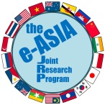
Ken Kawabata (Mr.)
e-ASIA JRP Secretariat / Japan Science and Technology Agency
Room 218 Innovation Cluster1 Building
National Science and Technology Development Agency (NSTDA)
111 Thailand Science Park, Phahonyothin Road
Khlong Nueng, Khlong Luang, Pathum Thani 12120 THAILAND
Tel: +66-2-564-7713 H/P: +66-61-421-0316
E-mail: easia_secretariat@jst.go.jp

